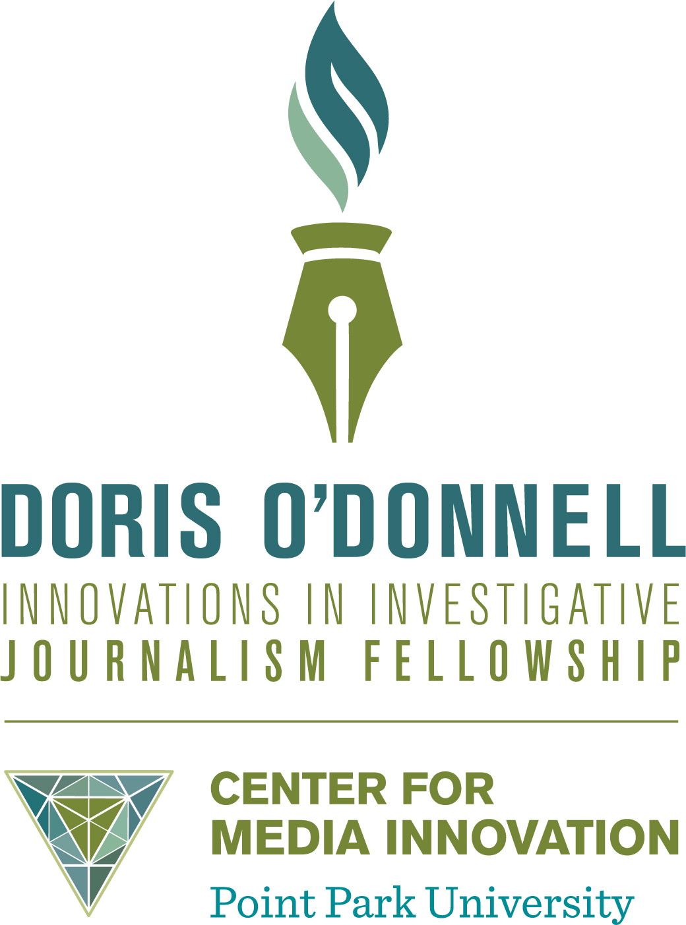

FELLOWSHIP CRITERIA

Description: Honoring the legacy of a media pioneer, the Doris O’Donnell Innovations in Investigative Reporting Fellowship provides journalists with the resources to tell groundbreaking stories in creative ways. The fellowship will be awarded to a journalist or news outlet in the United States that proposes a substantive reporting project that integrates innovative delivery methods, that reaches underserved markets known as “news deserts,” and that involves diverse populations.

Judging: A panel of five experts with credentials in innovative journalism will evaluate applicants based on the following criteria: value, innovation, engagement, diversity and ability. The judges independently will score each applicant using a rubric to identify 3-5 finalists. The panel will convene telephonically to discuss the finalists and determine a winner. The director of the Center for Media Innovation at Point Park University will serve as an ex-officio member of the evaluation team, moderating discussion, scoring applicants to determine finalists, and offering the deciding vote in the event of a tie.

Awarding: The Center for Media Innovation will announce the award in September of each year, and the winning journalist (the fellow) or news outlet will have six months to produce and publish or broadcast the final story or series of stories. If a news outlet receives the award, it must identify one person to serve as the fellow.

Fellowship: The fellow must agree to appear at Point Park University in Pittsburgh at least three times throughout the reporting project: once each during the fall and early spring semesters, and at an event the April following the award of the fellowship to celebrate the fellow’s work. This event will require the fellow to present her or his findings to a public audience at the Pittsburgh Playhouse, and to take questions, during an event that lasts approximately 60 minutes.

Payment to the fellow will occur in eight monthly installments of $2,000 each, with a final bonus of $4,000 upon completion.

Conditions: The fellow or their employer will own the intellectual property related to the work product created throughout the fellowship (“Work Product”). However, the fellow and their employer, if applicable, must agree to grant a non-exclusive license to Point Park University to use, distribute, and publicize all Work Product. The fellow must also grant the University the right to use their name and likeness for the purpose of publicizing the fellowship and Work Product.

