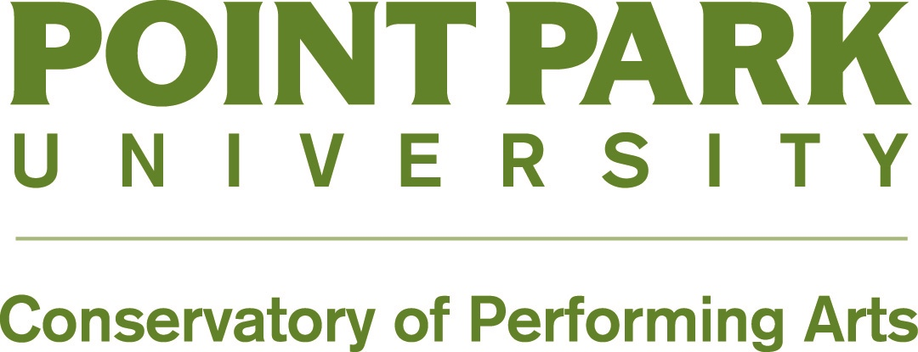

**School of Dance**

**Audition Guidelines**

**What to Expect on an In-Person and On-Campus Audition**

* On-campus audition day activities typically last from 8:30 a.m. to 2 p.m. Plan to spend your day on campus.
* A confirmation email will be sent one week prior to the audition day with approximate times and locations.
* Solo variations are not accepted.
* Parents are NOT permitted to observe the audition class.
* A campus tour, faculty Q&A session for auditioning students, and a parent/student Q&A session are included with the on-campus audition day.

**Training**

Dancers should currently be training at least ten hours per week for a minimum of three years and must have a working knowledge and understanding of the following principles:

* Proper placement specific to chosen genre or concentration
* Coordination
* Epaulement (body positions that create a sense of line connecting upper and lower body)
* Weight Shifting
* Adaptability or Versatility
* Musicality

Applicants should be proficient in their chosen concentration and have working knowledge in the other areas.

**What to Bring to Your Audition**

* Performance/training resume
* Headshot (8x10 in size)
* Full-body photograph in first arabesque for Ballet, Jazz or Modern concentrations is required (8x10 in size). *Dancers interested in the* ***ballet*** *concentration should be on pointe or relevé*.
* Dancers interested in the **hip hop** concentration may provide a movement photo in addition to the headshot, but not required.

Do **NOT** mail these materials prior to your audition. All materials submitted to Point Park University are **NON- RETURNABLE**.

**Audition Attire**

**Hair should be groomed and/or secured off the face and above the neck. Not hats, bandanas or headbands.**

**Ballet**

* Solid color leotard or fitted top and tights or unitard, ballet shoes
* **Pointe:** Only required for Ballet concentrations but optional for all concentrations. Pointe

**Modern**

* Solid color leotard or fitted top and tights or unitard, bare feet

**Jazz**

* Solid color leotard or fitted top and tights or black leggings or unitard, bare feet or jazz shoes

**Hip Hop:**

* Loose or form-fitted dance wear (nothing too revealing) including sweats, leggings, basketball shorts, tanks, t-shirts; comfortable tennis shoes or sneakers.

**Audition Class**

***Dancers will be observed in all disciplines***

* *The audition class will begin with a required ballet class for All*
* ***Pointe and/or allegro and turns*** *(only required of ballet concentration)*
* ***Modern*** *portion required for All*
* ***Jazz*** *portion required for All*
* ***Hip Hop*** *portion required for All*

**Audition Decisions**

Admittance into the School of Dance is based on talent and potential as demonstrated in the audition. Applicants must be academically and artistically admitted into Point Park University. Applicants **WILL NOT** receive their artistic decisions until they have received an academic decision from the Office of Admissions. Once the academic decision has been processed, artistic results will be sent out.

**Applicants will be notified by email and letter of their artistic decision and possible artistic achievement award as the academic and artistic decisions are made.**