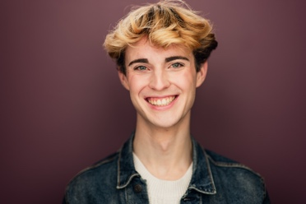**Sam Gibson**

Point Park University COPA 2025 – BFA Acting

(904-540-6186) [sammgibson1210@gmail.com](mailto:sammgibson1210@gmail.com)

Hair: Brown – Eyes: Blue – Height: 6’0” Voice Type: Baritenor – Vocal Range: G2-G4

THEATRE

12 Ophelia’s G Pittsburgh Playhouse: April Daras

The Trees Jared Pittsburgh Playhouse: Adil Mansoor

Newsies Finch / Crutchie U/S Pittsburgh Playhouse: Danny Herman

R&H Cinderella Ensemble Pittsburgh Playhouse: Tomé Cousins

Arcadia Septimus Hodge U/S Pittsburgh Playhouse: Phil Winters

*Waltz Choreographer

Kinky Boots Angel Player by the Sea : Joseph Kemper

SpongeBob SquarePants Plankton Players by the Sea: Joseph Kemper

She Kills Monsters Orcus/Ronnie Bridges Theater Co.: Madeline Bedford

Rent Ensemble/Mark U/S Dubow Theater: Joseph Kemper

Spring Awakening Ensemble/Hanschen U/S Player by the Sea: Bradley Akers

Lion and Mouse Story Devised Ensemble DuBow Theater: Bonnie Harrison

Guys and Dolls Emcee/Ensemble DuBow Theater : Joseph Kemper

Newsies Featured Dance Ensemble Florida State College : Michael Lipp

Curtains Ensemble DuBow Theater: Joseph Kemper

FILM

|  |  |  |
| --- | --- | --- |
| Lost In a Dream | Lead | DASOTA: Elizabeth Arcenuex |
| A Brothers Love | Featured Extra | DASOTA: Elizabeth Arcenuex |

TRAINING - Point Park University 2025 – BFA Acting

Acting Kim Weild, Milia Ayache, Phil Winters, Meg Pryor, Chris Clavelli

Voice Devin Clevenger, Lisa Brovey-Kovach, Regina Torres

Dance Michelle Van Doeren, Robert McKee, Ellie Barrett

Suzuki Christopher Staley

Alexander Technique Bonnie Harrison & Emily Sapa

Fitzmaurice John Gresh

Meisner Chris Clavelli

Étude’s Milia Ayache

SPECIAL SKILLS **Dance**: Choreography, Ballet, Tap, Jazz, Modern, Beginner Ballroom, Toe Touch and Cartwheels. **Voice:** RP, Cockney Gulf & Mountain Southern, New York and Irish (Trained with the International Phonetic Alphabet), Mickey Mouse Impression, Valid Passport,