- Go to https://pointpark.bncollege.com/
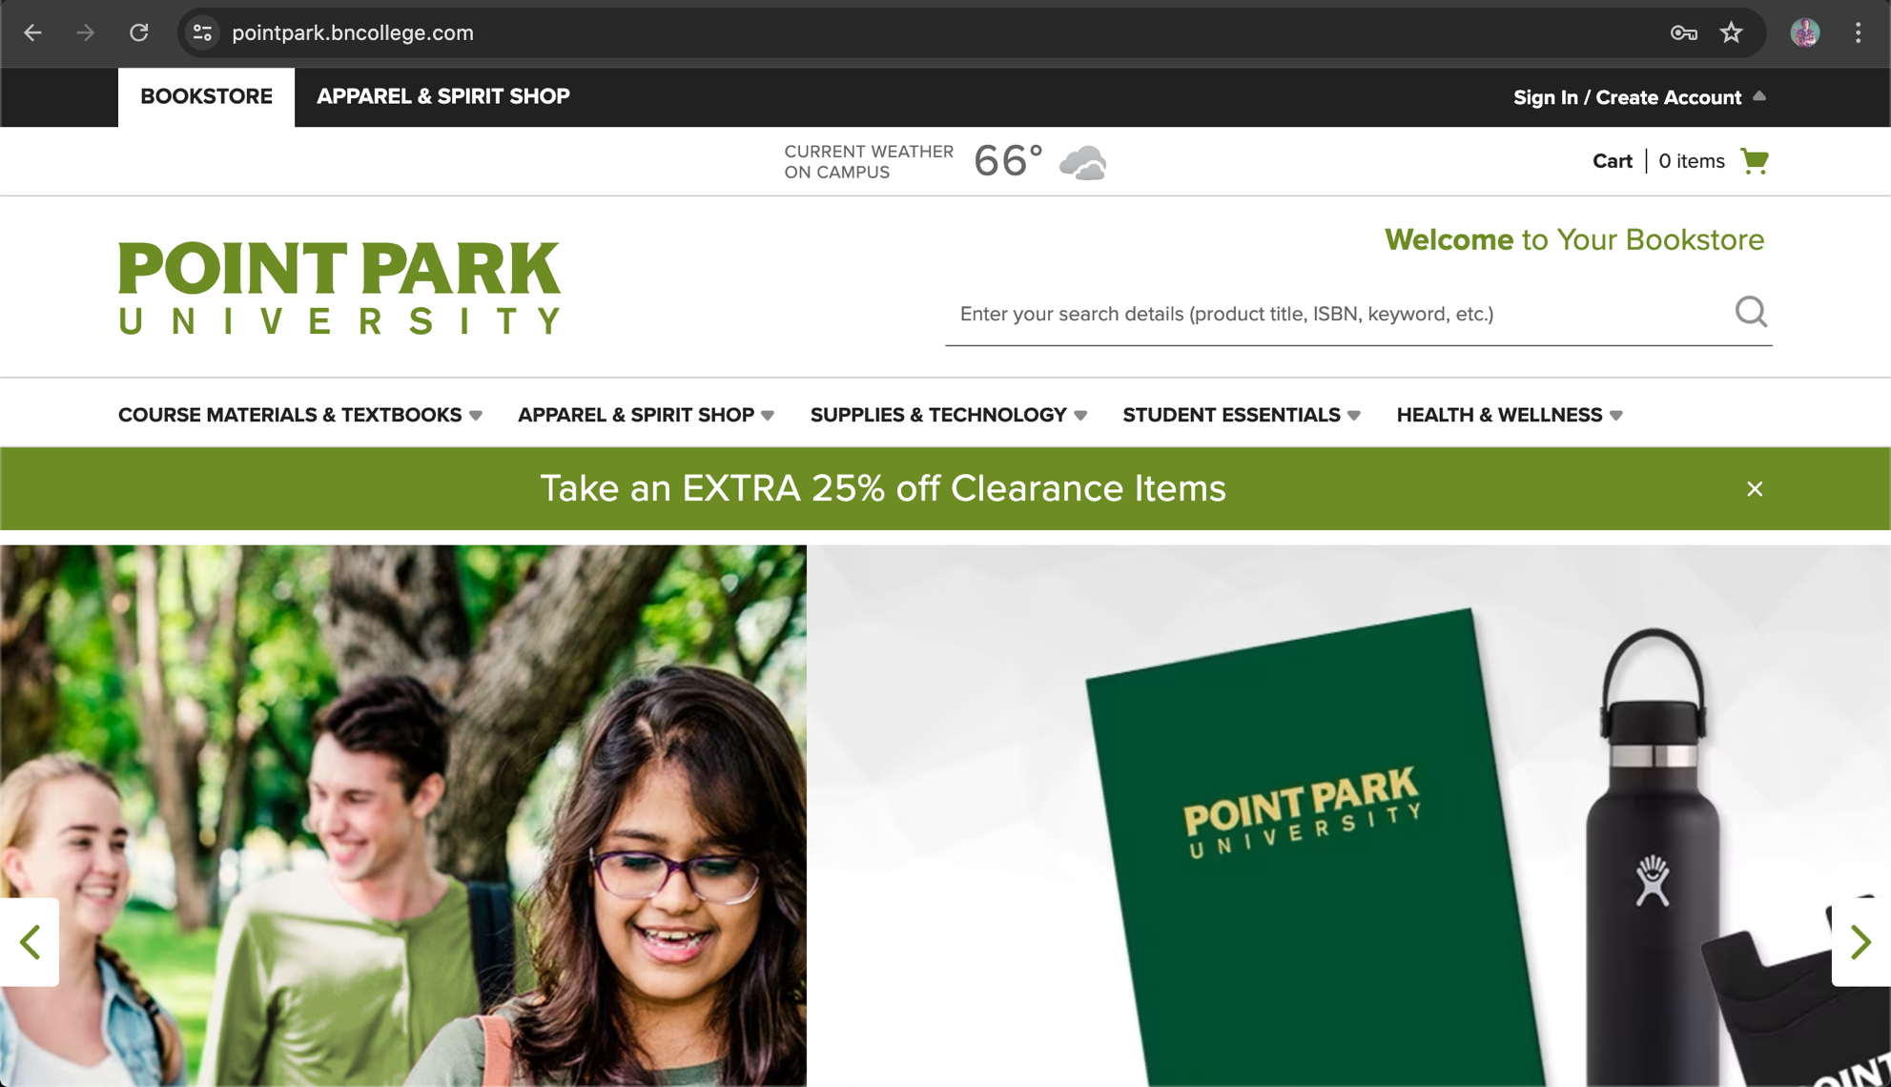

- Scroll down and select Course Materials Concierge
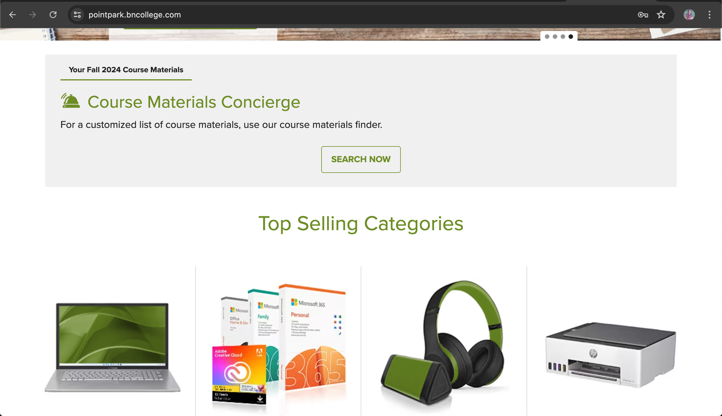

- Start logging your courses (term, department, course number, AND sections) into the concierge. Select ANY section that begins with “O” for online courses.
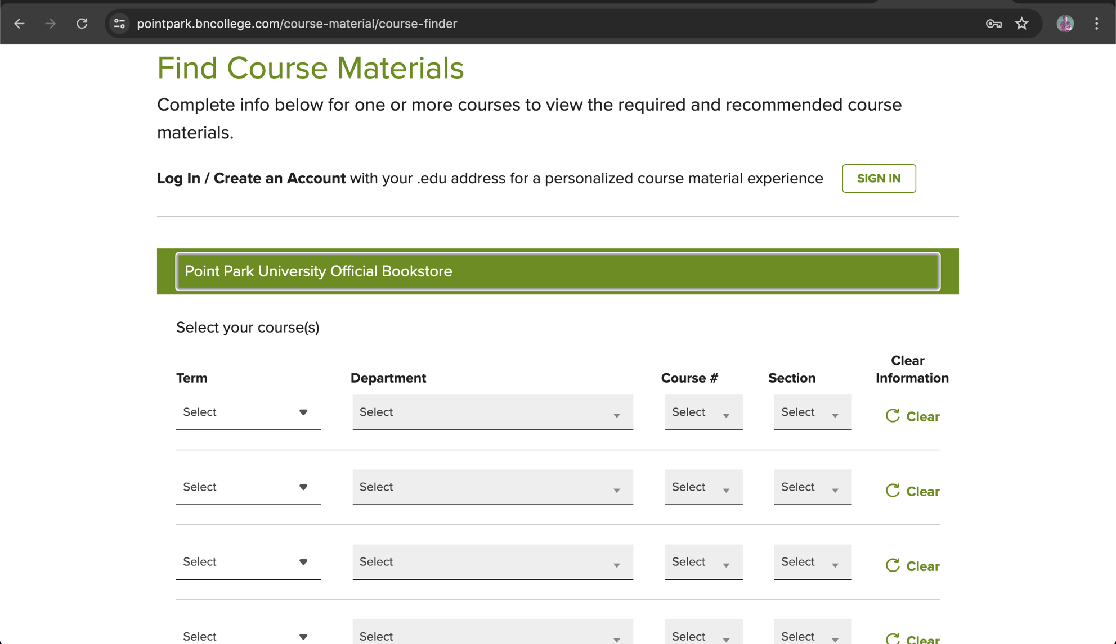

- Entire each of your classes into the concierge
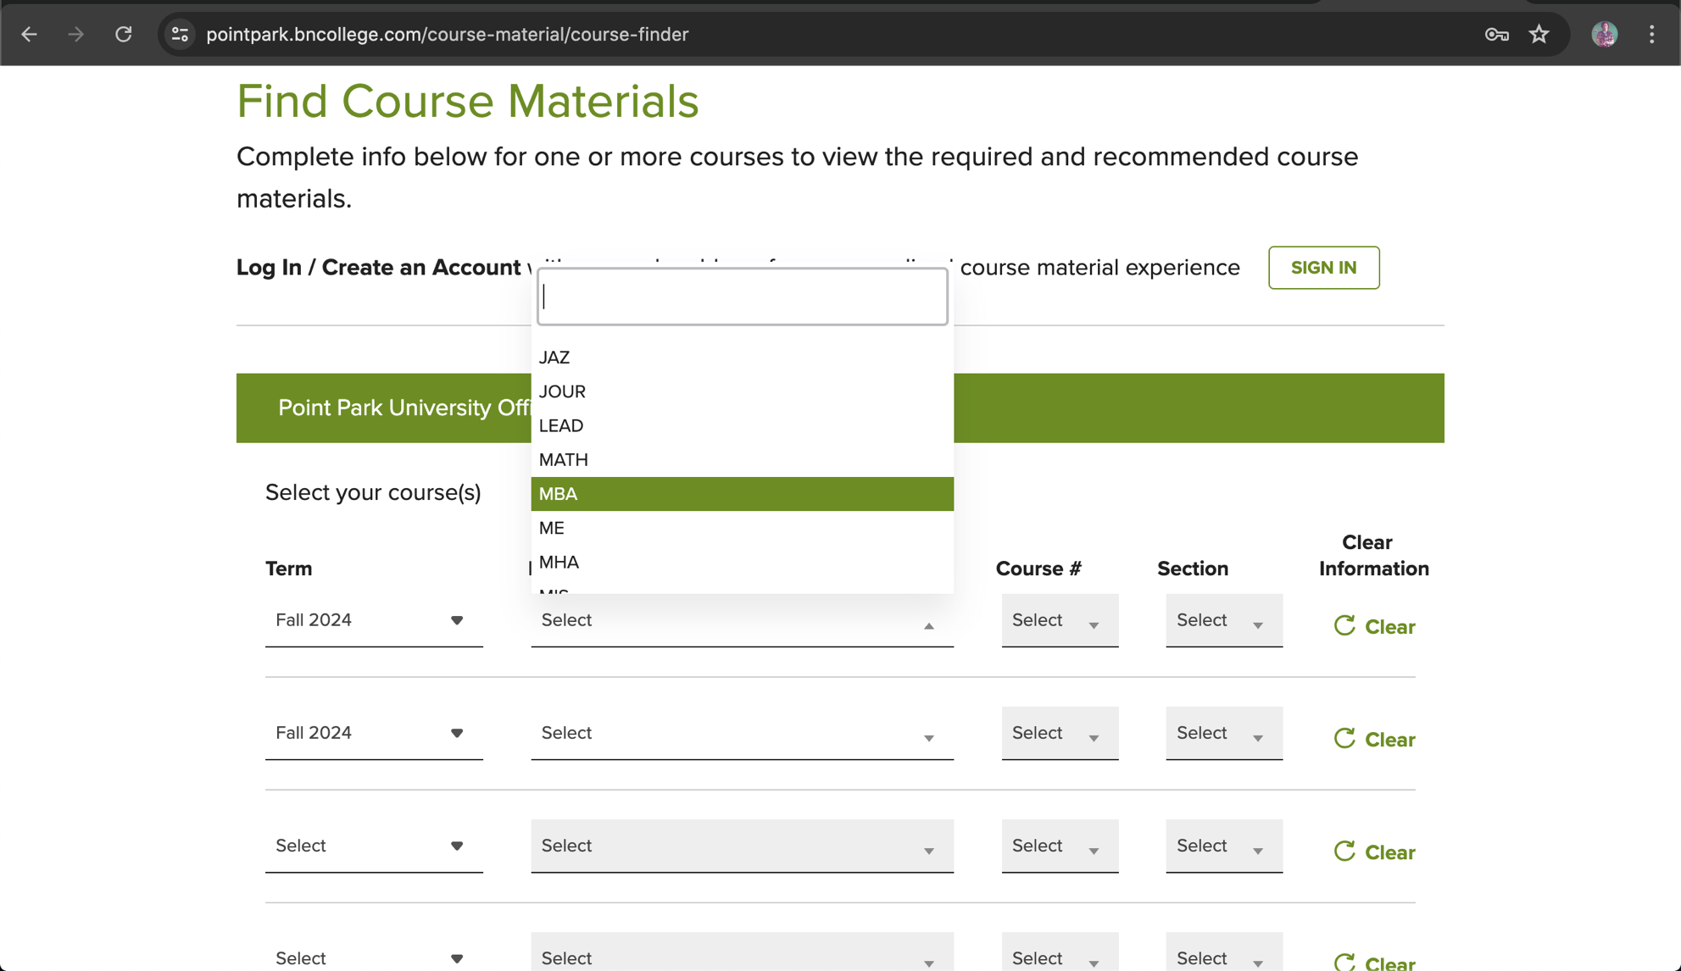

- Select Retrieve Materials
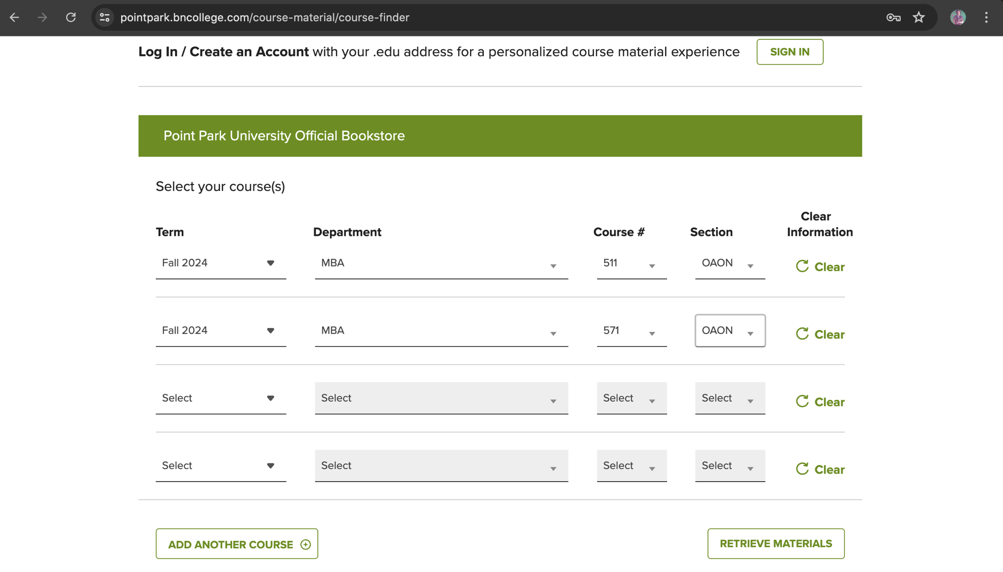

- Your course materials will appear on the next page. You can choose to rent them through the bookstore or external merchants (Amazon, Chegg, Half Price Books, etc.). If a textbook is required to be digital, you are encouraged to do that.
